SESSION 1:-

In the following figure, you can see a rectangular :-

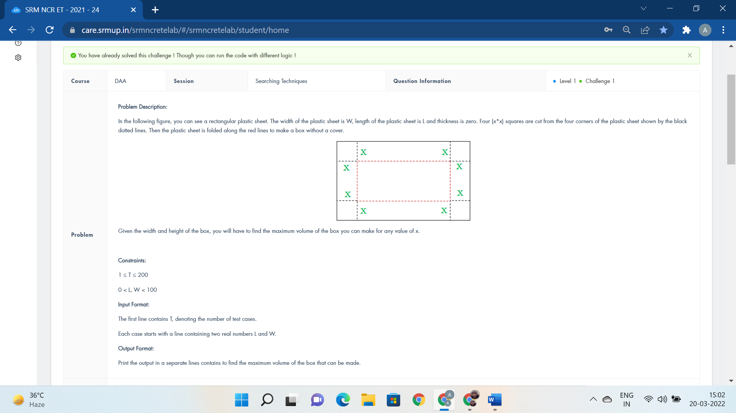

#include <bits/stdc++.h>

using namespace std;

void solve(){

cout<<"return(l-2*x)*(b-2*x)*x;";

}

int main()

{

int tc;

double a, b, c, res, l, w, x;

scanf(" %d", &tc);

while(tc--) {

scanf(" %lf %lf", &l, &w);

a = 12.0;

b = -4.0 * (l+w);

c = l*w;

x = (-b - sqrt (b*b - 4.0*a*c)) / (2.0*a);

res = (l - 2*x) * (w - 2*x) * x;

printf ("%.9f\n", res);

}

return 0;

}

Mr. somu has another problem for Agi today.

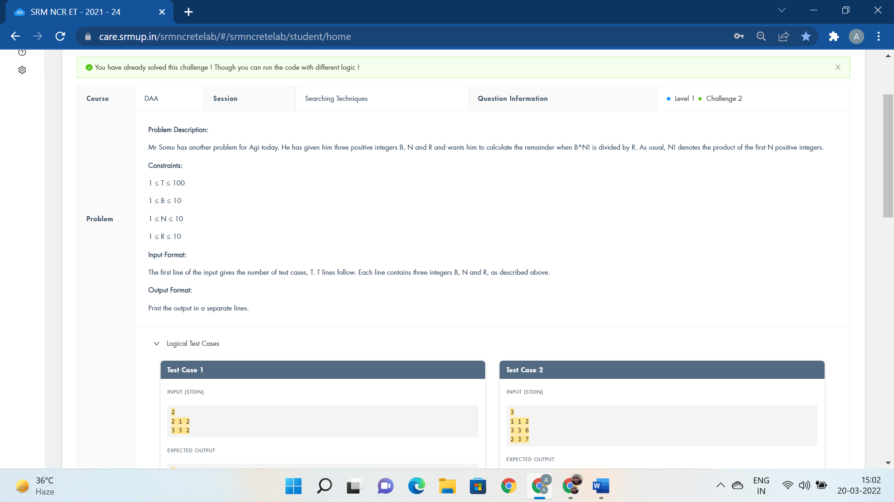

#include<bits/stdc++.h>

using namespace std;

int main()

{

int t;

cin>>t;

while(t--){

int b,n,r;

cin>>b>>n>>r;

int z=1;

for(int i=1;i<=n;i++){

z=z*i;

}

int res;

res=pow(b,z);

cout<<res%r<<endl;

}

return 0;

cout<<"if(n%2==1)";

}

Major Kathiravan has a chart of distinct :-

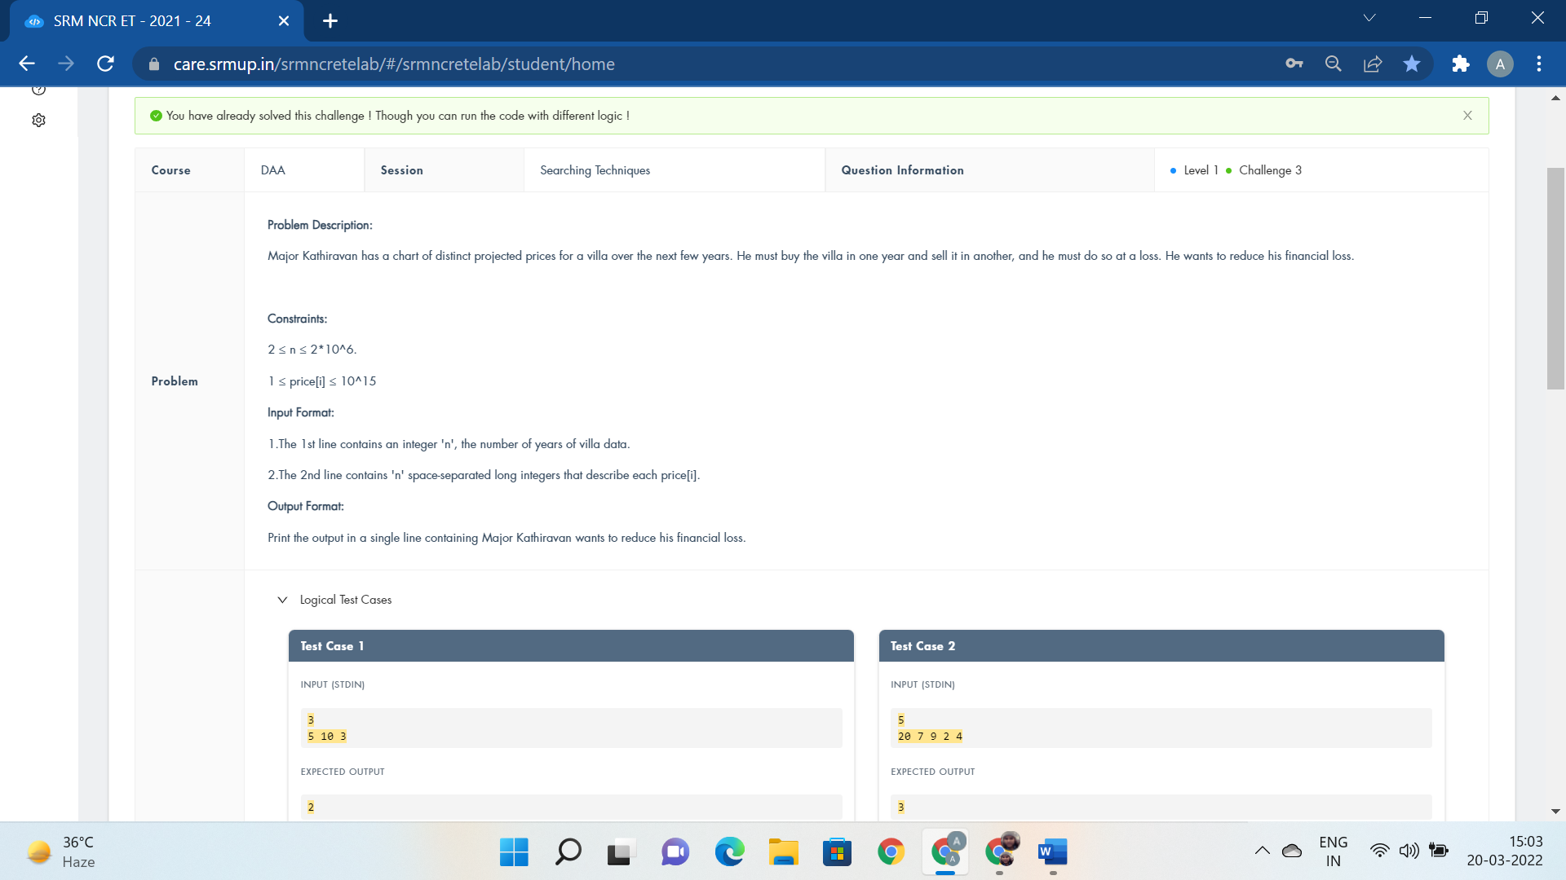

#include<bits/stdc++.h>

#define f(n) for(int i=0;i<n;i++)

using namespace std;

int main()

{

int n;

cin>>n;

int arr[n];

int res=10000;

f(n){

cin>>arr[i];

}

f(n){

for(int j=i+1;j<n;j++){

if(arr[i]>arr[j]){

res=min(res,arr[i]-arr[j]);

}

}

}

cout<<res;

return 0;

cout<<"while";

}

The allies are trying to get a message

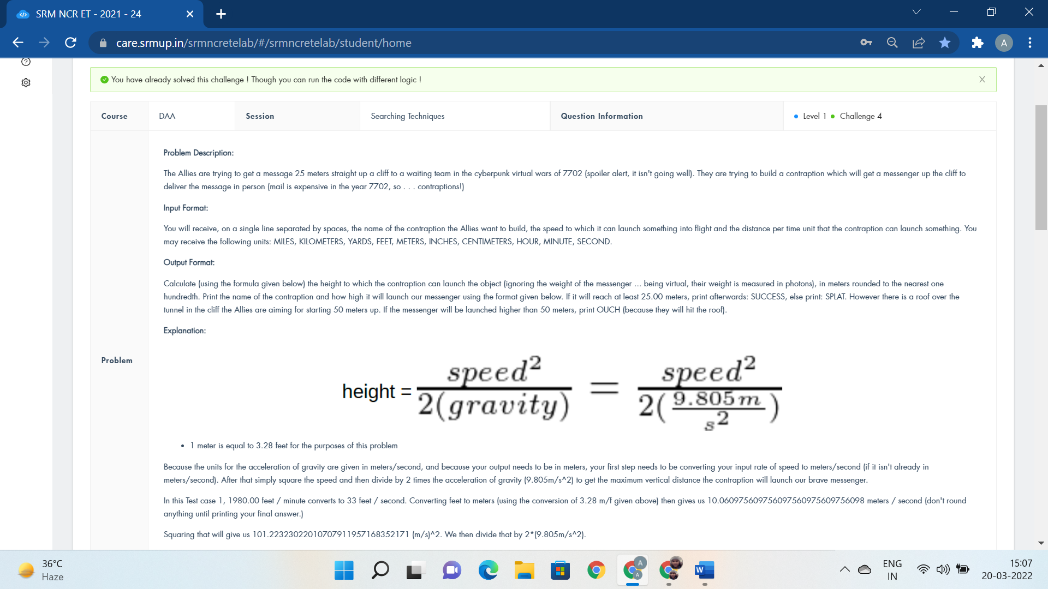

#include<bits/stdc++.h>

using namespace std;

void solve(){ cout<<"break;"; }

int main(){

string s1,s2,s3,s4;

double r;

double h;

cin>>s1>>r>>s2>>s3>>s4;

if(s2=="FEET")

r=r/3.28;

//cout<<r<<endl;

if(s2=="KILOMETERS") r=r*1000;

if(s2=="YARDS") r=r*0.9144;

if(s2=="INCHES") r=r*0.0254;

if(s2=="MILES") r=r*1609.34;

if(s4=="HOUR") r=r/3600;

if(s4=="MINUTE") r=r/60;

if(s2=="CENTIMETERS") r=r/100;

h=r*r/(2*9.805);

cout<<s1<<" will launch the message "<<fixed<<setprecision(2)<<h<<" meters high, ";

if(h>50) cout<<"OUCH!";

else if(h<25) cout<<"SPLAT!";

else cout<<"SUCCESS!";

return 0; }

Given ‘m’ positive integers denoting an upgrading map :-

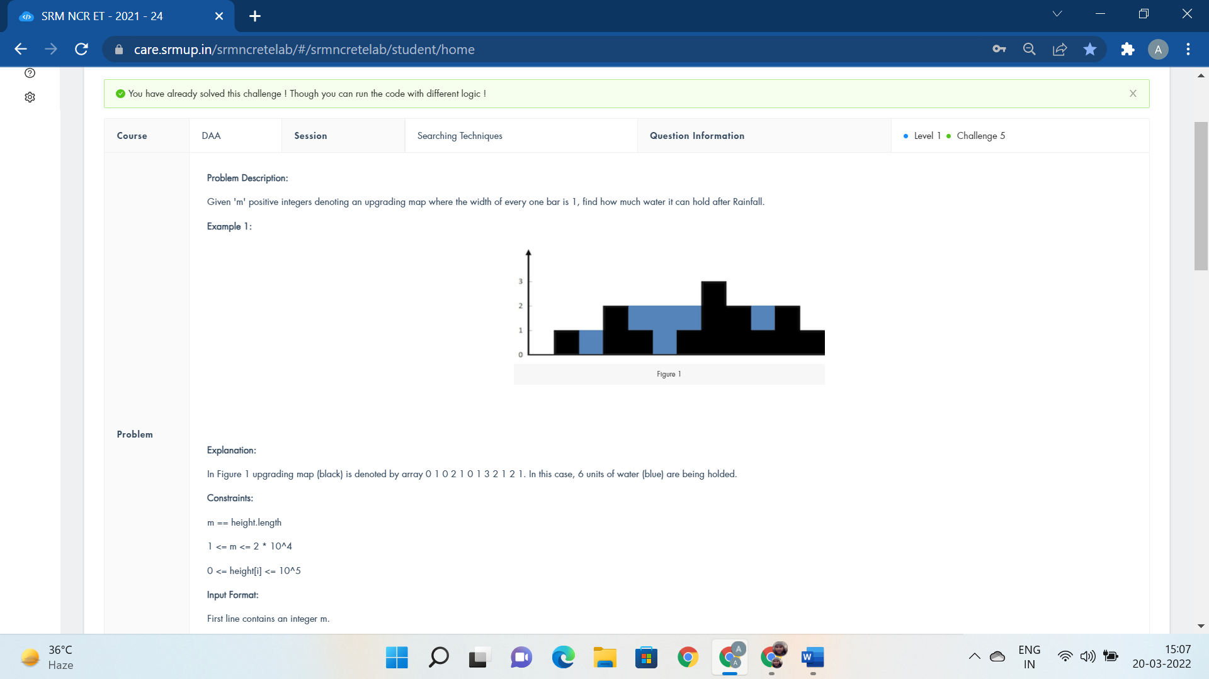

#include <bits/stdc++.h>

using namespace std;

#define f(n) for(i=0;i<n;i++)

#define g(n) for(i = 1; i < n; i++)

#define k(n) for(i=n-2;i>=0;i--)

int maxWater(int arr[], int n)

{

int left[n],i;

int right[n];

int water = 0;

left[0] = arr[0];

g(n)

left[i] = max(left[i - 1], arr[i]);

right[n - 1] = arr[n - 1];

k(n)

right[i] = max(right[i + 1], arr[i]);

for(i = 1; i < n-1; i++)

{

int var=min(left[i-1],right[i+1]);

if(var > arr[i])

{

water += var - arr[i];

}

}

return water;

}

int main()

{

int n,i;

cin>>n;

int arr[n];

f(n){

cin>>arr[i];

}

cout << maxWater(arr, n);

return 0;

}

The Mask ate a block of dynamite to save :-

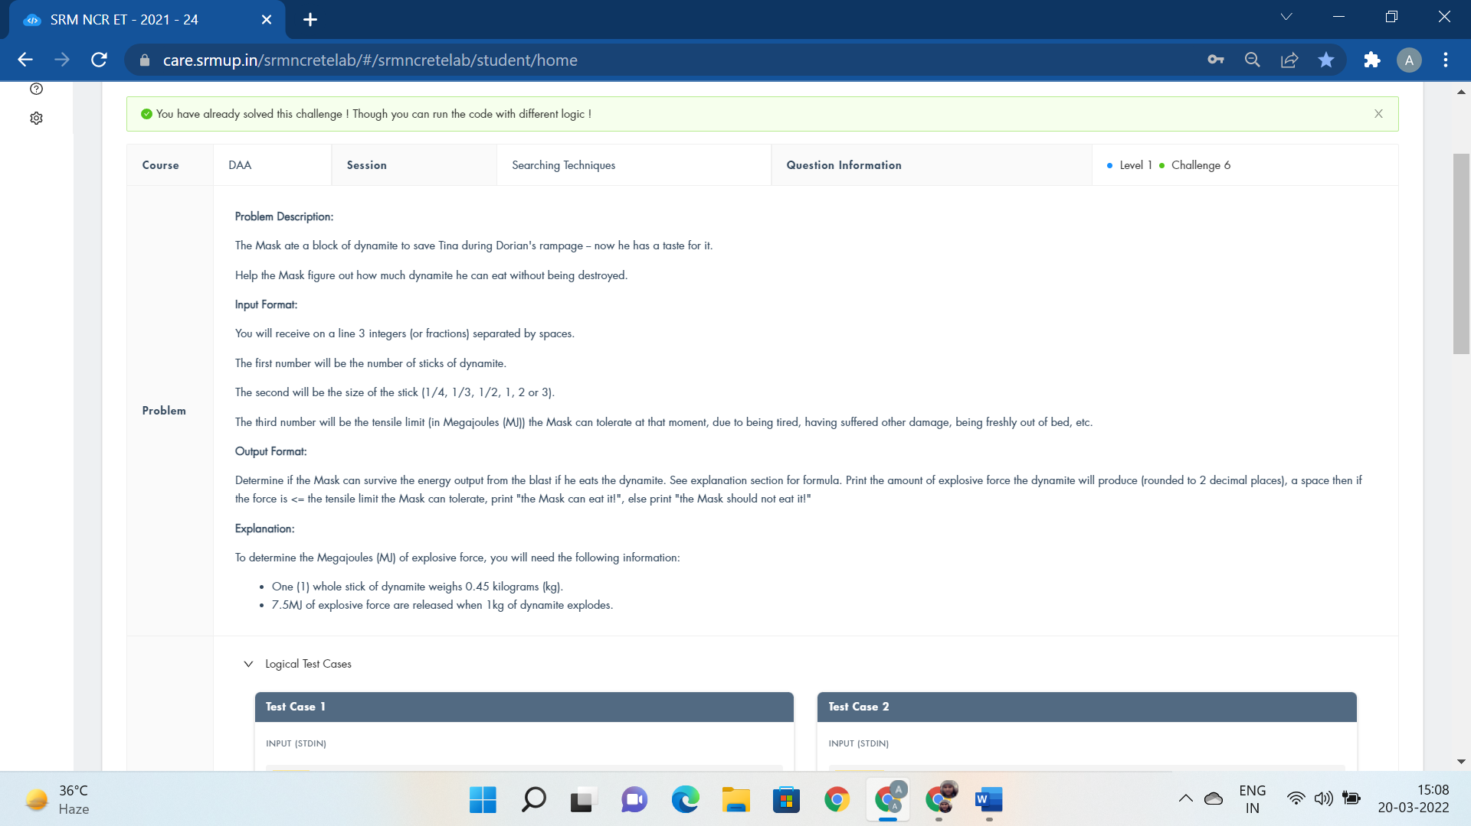

#include <bits/stdc++.h>

using namespace std;

int main()

{

float a,c,d;

string b;

cin>>a>>b>>c;

float res;

int z=b.size();

if(z==1)

d=b[0]-48;

else

d=(float)(b[0]-48)/(b[2]-48);

res=a*d*0.45*7.5;

if(res>c){

cout<<res<<" the Mask should not eat it!";

}

else

cout<<fixed<<setprecision(2)<<res<<" the Mask can eat it!";

return 0;

cout<<"for";

}

There is a Gangaroo initially placed at the :-

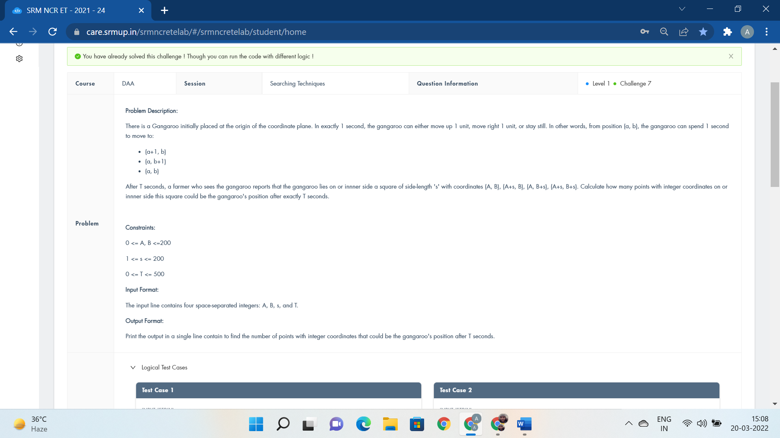

#include <stdio.h>

int main(){

int x,y,s,t,i,j,count=0;

scanf("%d", &x);

scanf("%d", &y);

scanf("%d", &s);

scanf("%d", &t);

for(i=x;i<=x+s;i++){

for(j=y;j<=y+s;j++){

if(i+j<=t)

count++;

}

}

printf("%d",count);

return 0;

printf("if(s>=t)if(s<=t/2)");

}

Inspector Gadget just installed new springs :-

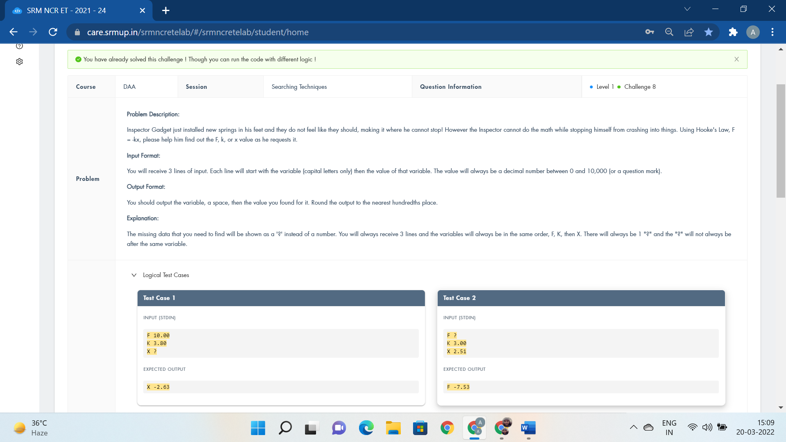

#include<bits/stdc++.h>

using namespace std;

int main()

{

string s1,s2,s3,s4,s5,s6;

cin>>s1>>s2>>s3>>s4>>s5>>s6;

float a,b,c;

if(s2=="?"){

b=stof(s4);

c=stof(s6);

//cout<<c;

cout<<"F "<<fixed<<setprecision(2)<<(-b)*c;

}

else if(s4=="?"){

a=stof(s2);

c=stof(s6);

cout<<"K "<<fixed<<setprecision(2)<<a/(-c);

}

else

{

a=stof(s2);

b=stof(s4);

cout<<"X "<<fixed<<setprecision(2)<<a/(-b);

}

return 0;

}

A double-square number is an integer Y which can be :-

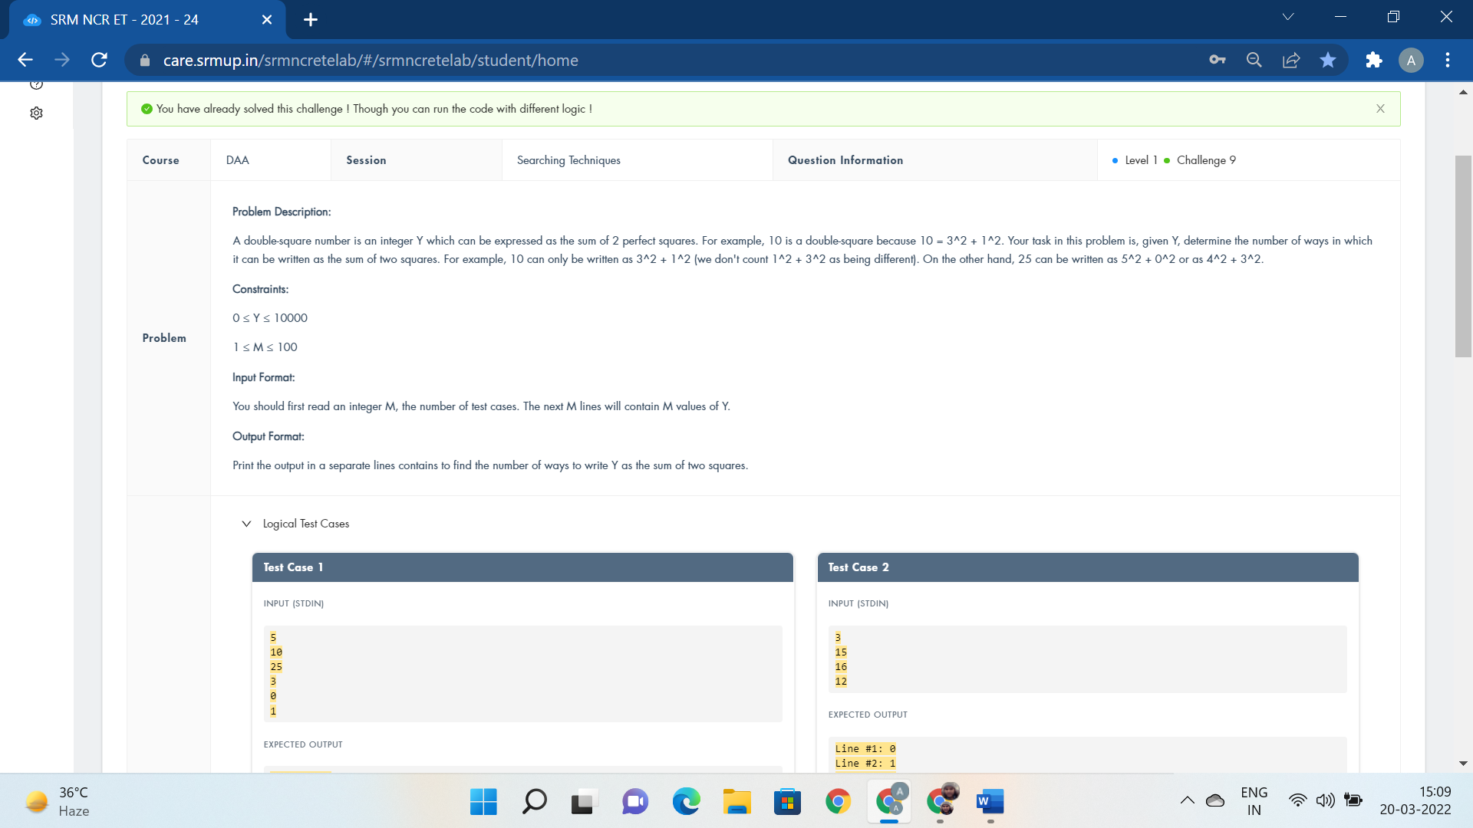

#include <bits/stdc++.h>

using namespace std;

int sumSquare(int n)

{

int res=0;

for (long i = 0; i * i <= n; i++)

for (long j = i; j * j <= n; j++)

if ((i * i + j * j == n) ) {

res++;

}

return res;

}

int main()

{

int t;

cin>>t;

int i=1;

while(t--){

int n;

cin>>n;

cout<<"Line #"<<i<<": "<<sumSquare(n)<<endl;

i++;

}

return 0;

cout<<"for(i=0;i<=sqrt(y);i++) for(j=0;j<=i;j++)";

}

Given two integers: ‘b’ and ‘a’

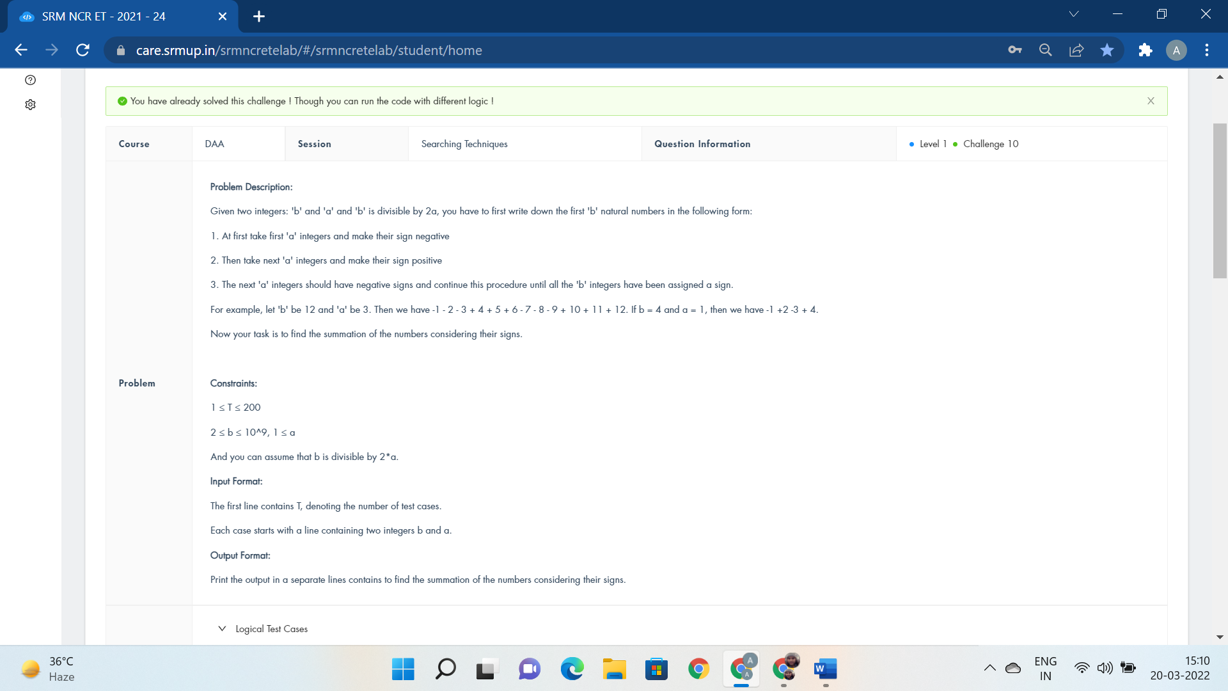

#include <iostream>

using namespace std;

int main()

{

int t;

long long m;

long long n;

long long ans;

scanf("%d", &t);

for (int cs = 1; cs <= t; cs++) {

scanf("%lld %lld", &n, &m);

ans = (n * m ) / 2;

printf("%lld\n",ans);

}

}

SESSION 2:-

Great news! You get to go to Japan :-

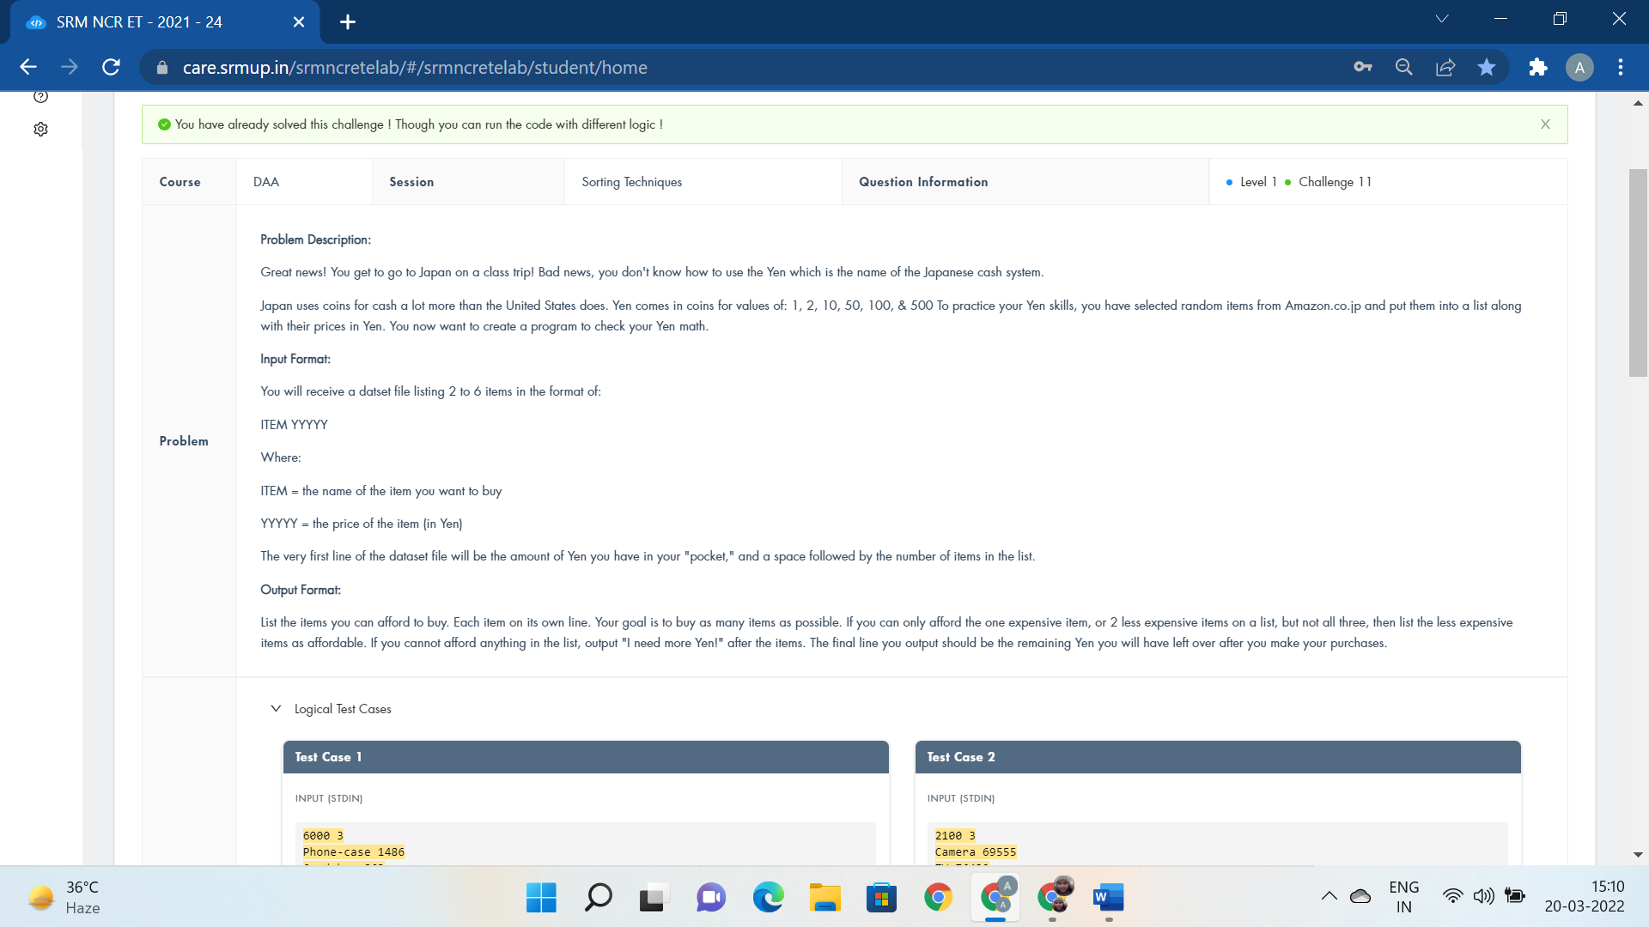

#include<iostream>

using namespace std;

int main()

{

int items;

int a,j,cnt=0;

cin>>a>>items;

int c[items];

string s[items];

for(j=0;j<items;j++){

cin>>s[j]>>c[j];

if(c[j]<a){

cout<<"I can afford "<<s[j]<<endl;

a=a-c[j];

}

else{

cnt++;

cout<<"I can't afford "<<s[j]<<endl;

}

//cout<<cnt;

}

if(cnt==items)

cout<<"I need more Yen!";

else

cout<<a;

return 0;

cout<<"for(i=1;i<=yen;i++) int i,j;";

}

Scrooge Mcduck’s vault is practically :-

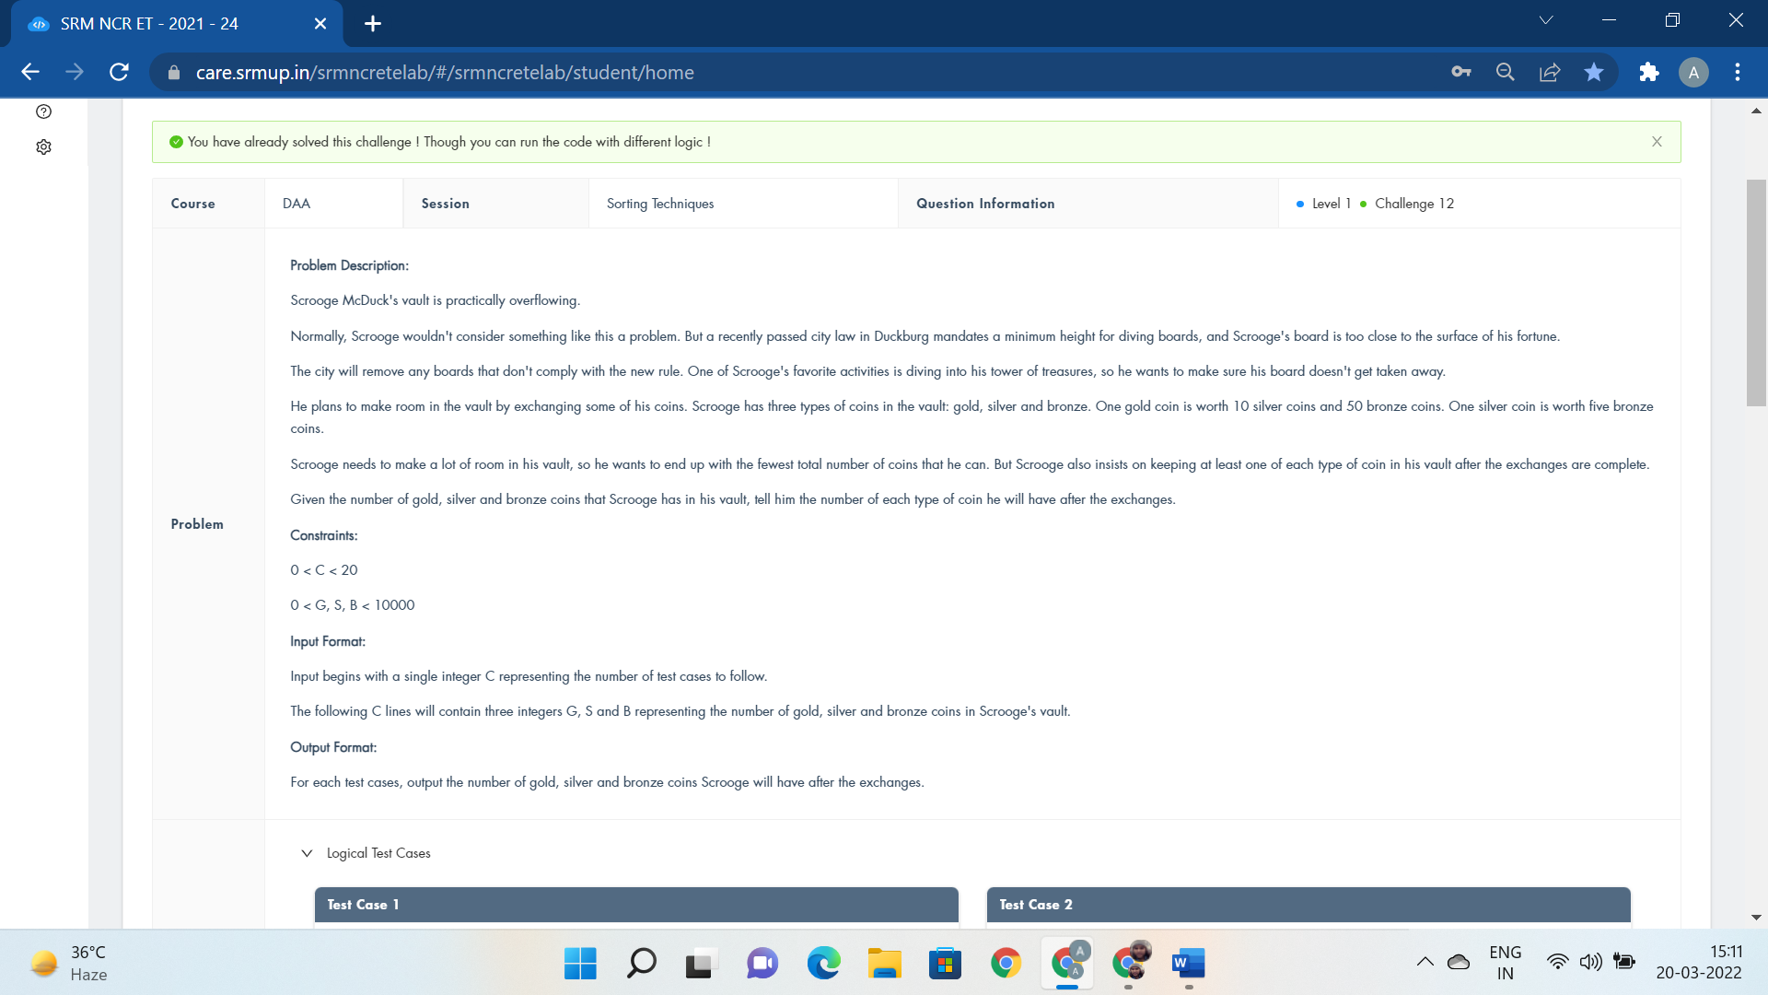

#include<iostream>

using namespace std;

int main()

{

int p,q,r,i;

int c;

cin>>c;

for(i=0;i<c;i++){

cin>>p>>q>>r;

q=q+(r-1)/5;

r=(r-1)%5+1;

p=p+(q-1)/10;

q=(q-1)%10+1;

cout<<p<<" ";

cout<<q<<" ";

cout<<r<<endl;

}

return 0;

}

Tina owns a match making company, which even to her :-

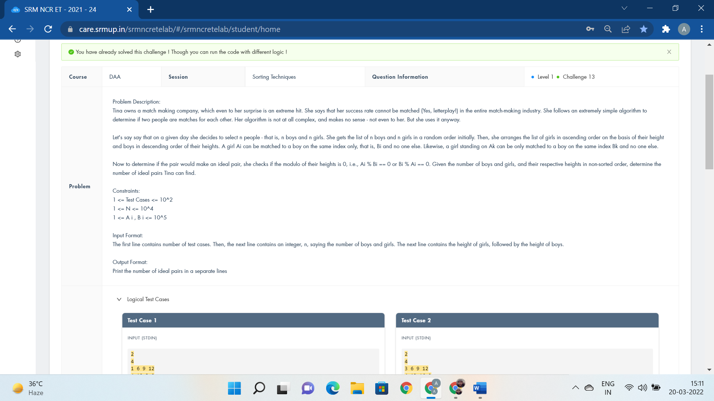

#include<bits/stdc++.h>

using namespace std;

int main()

{

int t,n;

cin>>t;

while(t--){

cin>>n;

int a[n],b[n],sum=0;

for(int i = 0;i<n;i++)

cin>>a[i];

for(int i=0;i<n;i++)

cin>>b[i];

sort(a,a+n);

sort(b,b+n);

for(int i=0;i<n;i++){

if(a[i]%b[n-i-1]==0 || b[n-i-1]%a[i]==0)

sum++;

}

cout<<sum<<endl;

}

return 0;

}

Ace ventura, pet detective, is on the hunt for a rare :-

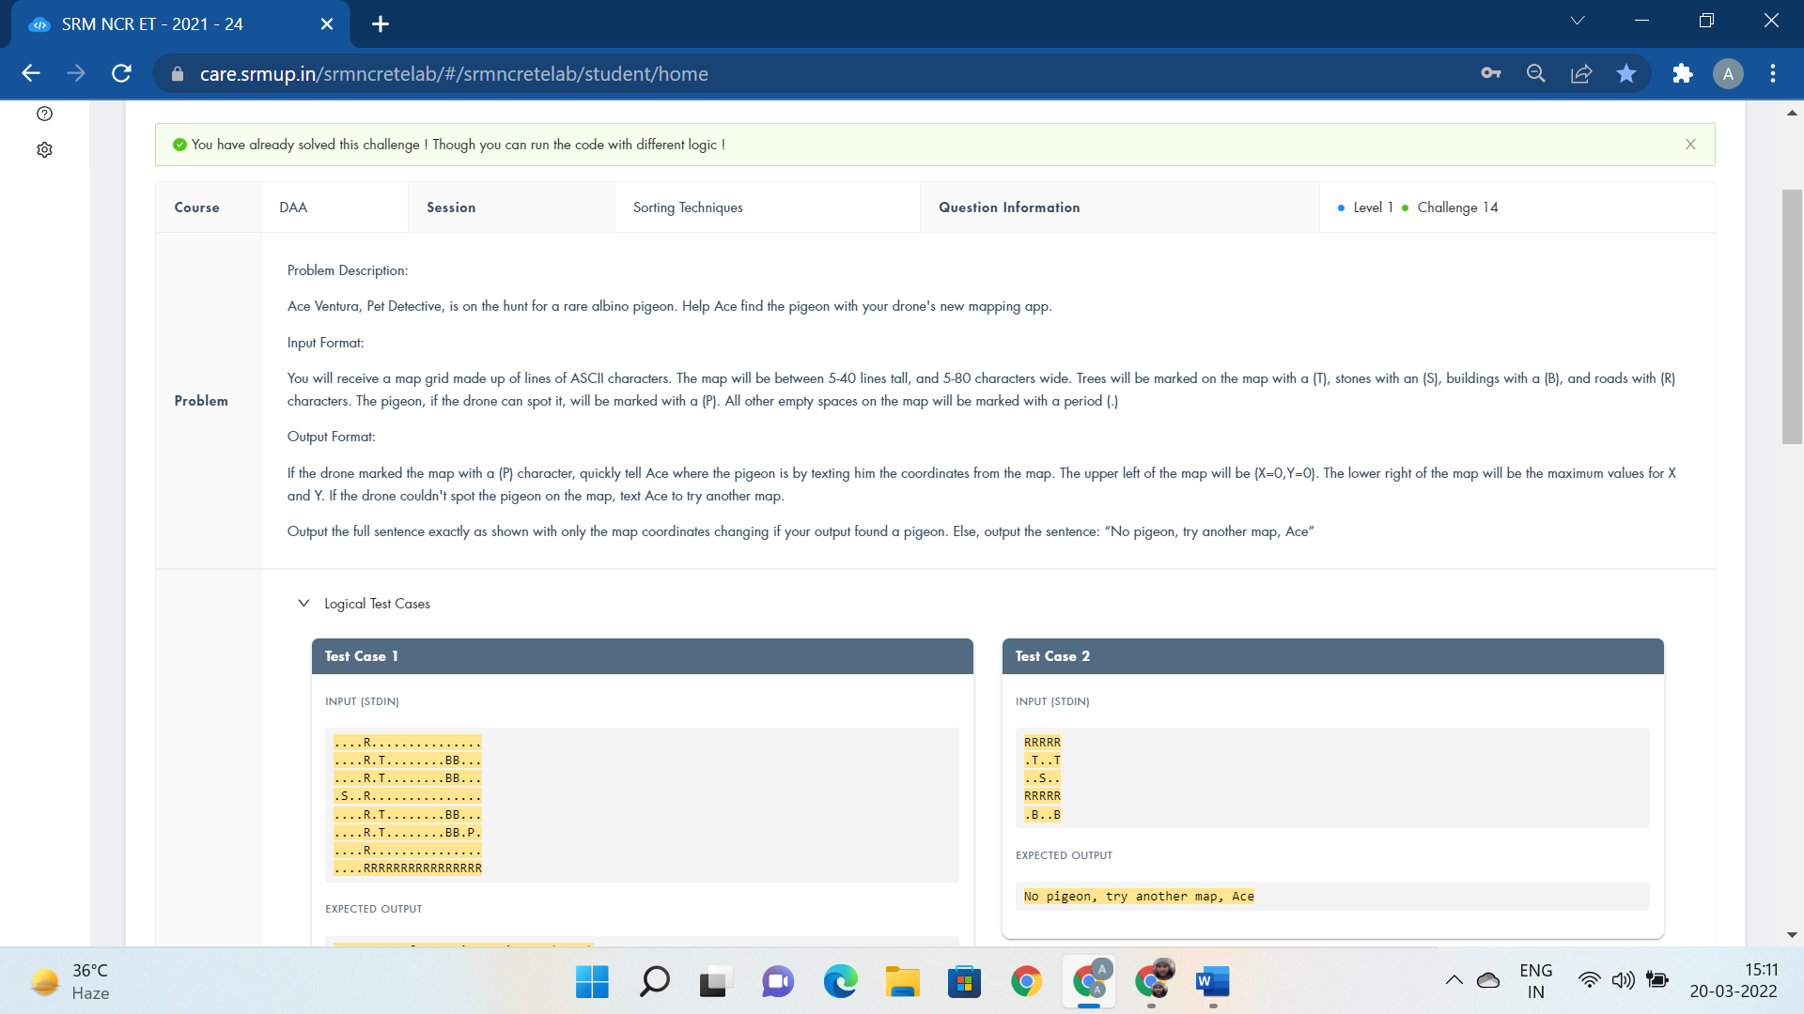

#include<bits/stdc++.h>

using namespace std;

#define p1 cout<<"Ace, move fast, pigeon is at ("<<i<<",0)";

#define p2 cout<<"Ace, move fast, pigeon is at ("<<(i-i/z)%z<<","<<i/z<<")";

#define p3 cout<<"No pigeon, try another map, Ace";

#define a continue;

#define f(n) for(int i=0;i<z;i++)

#define while1 while((scanf("%c",&s[i])) != EOF)

int main(){

string s1; cin>>s1;

int z=s1.size();

f(n){

if(s1[i]=='P'){ p1

return 0;}

}

//cout<<z<<endl;

int i=0,cnt=0;

char s[10000];

while1 {

if(s[i]=='P'){

cnt=1;

break;

}

i++;

}

if(cnt==1) p2

else p3 }

The sapphire consulting and marketing company is adding :-

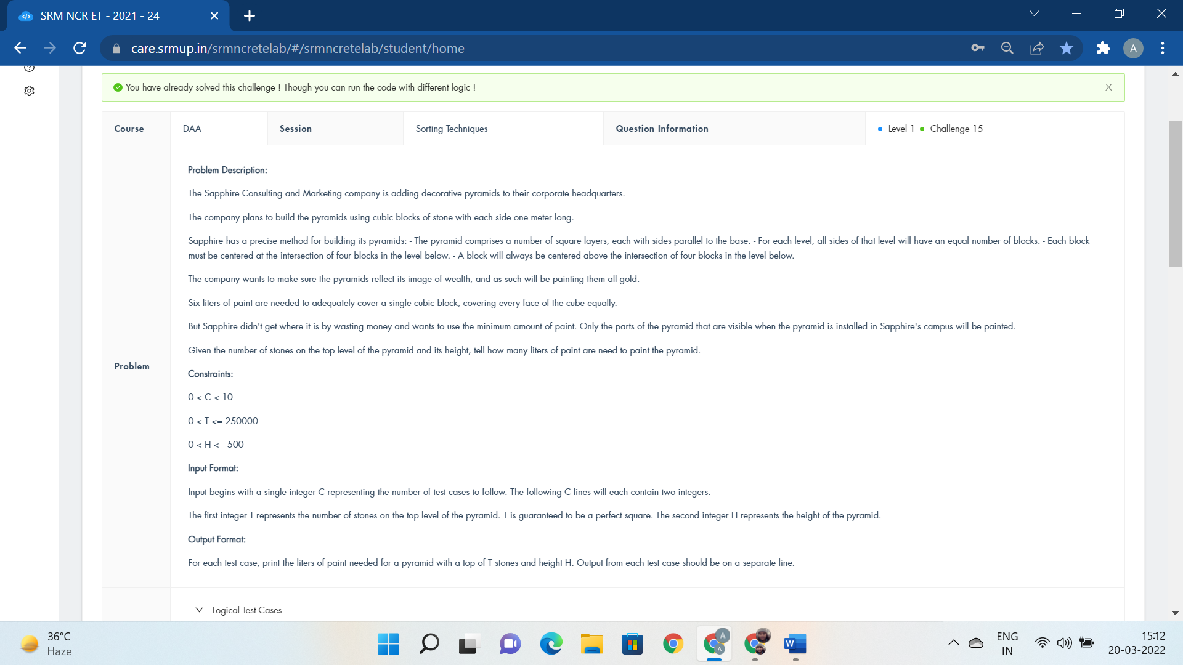

#include <stdio.h>

#include <stdlib.h>

int isqrt(n) int n; {

int i;

for(i=0;i*i<n;i++);

return i;

}

int main() {

int c;

int t,h,s,i,j;

int d;

scanf("%d",&c);

for(i=0;i<c;i++) {

s=0;

scanf("%d %d",&t,&h);

d=isqrt(t);

s+=t+(d*4);

for(j=1;j<h;j++) {

s+=3;

s+=(d+j)*4;

if((d+j)>2)

s+= (d+j-2)*2;

}

printf("%d liters\n",s);

}

return 0;

}

Ganesan has a string S consisting of lowercase:-

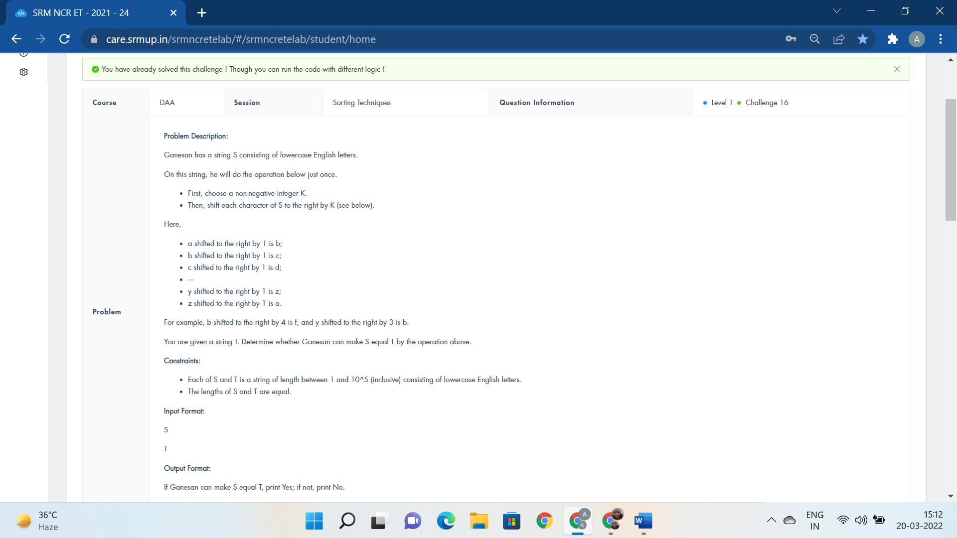

#include<bits/stdc++.h>

using namespace std;

int main()

{

string s,s2;

cin>>s>>s2;

int z = s.length();

int i;

int a[z];

for(i=0;i<(int)s.length();i++){

a[i]=s[i+1]-s[i];

}

for(int i=0;i<z-2;i++){

if(a[i]!=a[i+1]){

cout<<"No";

return 0;}

}

cout<<"Yes";

return 0;

}

RSA is a public key cryptosystem.

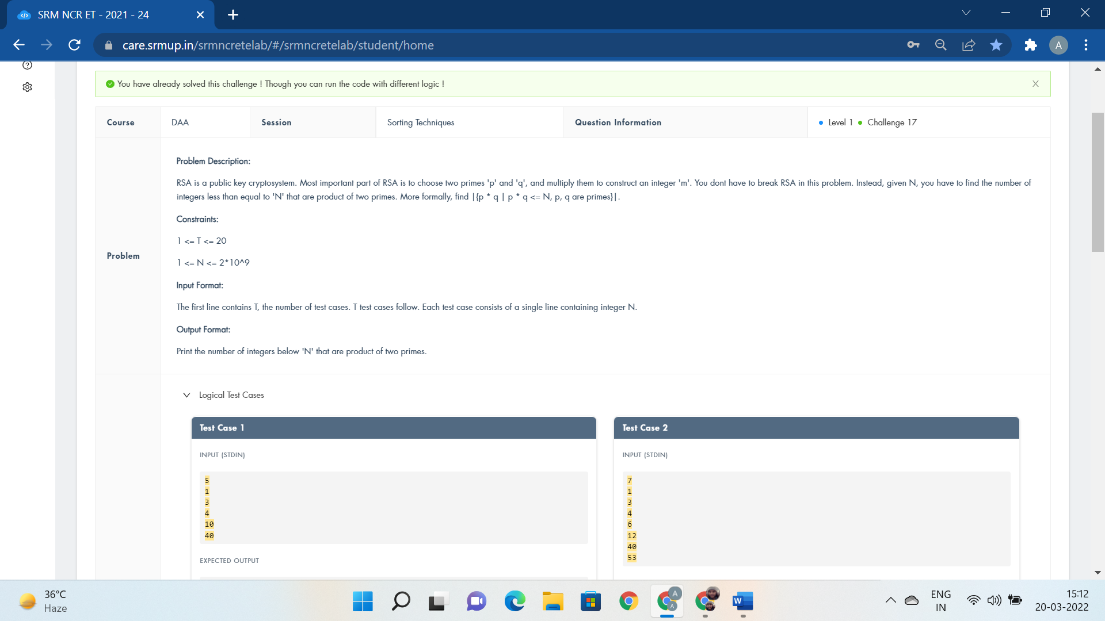

#include <bits/stdc++.h>

using namespace std;

void solve(){

cout<<"break;";

}

bool isProduct(int num)

{

int cnt = 0;

for (int i = 2; cnt < 2 && i * i <= num; ++i) {

while (num % i == 0) {

num /= i;

++cnt;

}

}

if (num > 1)

++cnt;

return cnt == 2;

}

void findNumbers(int N)

{

vector<int> vec;

for (int i = 1; i <= N; i++) {

if (isProduct(i) ) {

vec.push_back(i);

}

}

cout<<vec.size()<<endl;

}

int main()

{

int t,N;

cin>>t;

while(t--){

cin>>N;

findNumbers(N);

}

return 0;

}

ROYGBIV isn’t just an acronym, it’s a way of life :-



#include<bits/stdc++.h>

using namespace std;

void solve(){

cout<<"for break;";

}

int main()

{

int t=4;

while(t--){

string s1,s2;

cin>>s1>>s2;

if(s2=="WHITE")

cout<<"LIGHT "<<s1<<endl;

else if(s2=="BLACK")

cout<<"DARK "<<s1<<endl;

else if(s1=="WHITE")

cout<<"LIGHT "<<s2<<endl;

else if(s1=="BLACK")

cout<<"DARK "<<s2<<endl;

else if((s1=="RED"&&s2=="YELLOW")||(s1=="YELLOW"&&s2=="RED"))

cout<<"ORANGE"<<endl;

else if((s1=="BLUE"&&s2=="YELLOW")||(s1=="YELLOW"&&s2=="BLUE"))

cout<<"GREEN"<<endl;

else if((s1=="BLUE"&&s2=="RED")||(s1=="RED"&&s2=="BLUE"))

cout<<"PURPLE"<<endl;

else if(s1==s2)

cout<<s1<<endl;

else

cout<<"N/A"<<endl;

}

return 0;

}

The people of vadipatti have decided to paint each of their villas :-

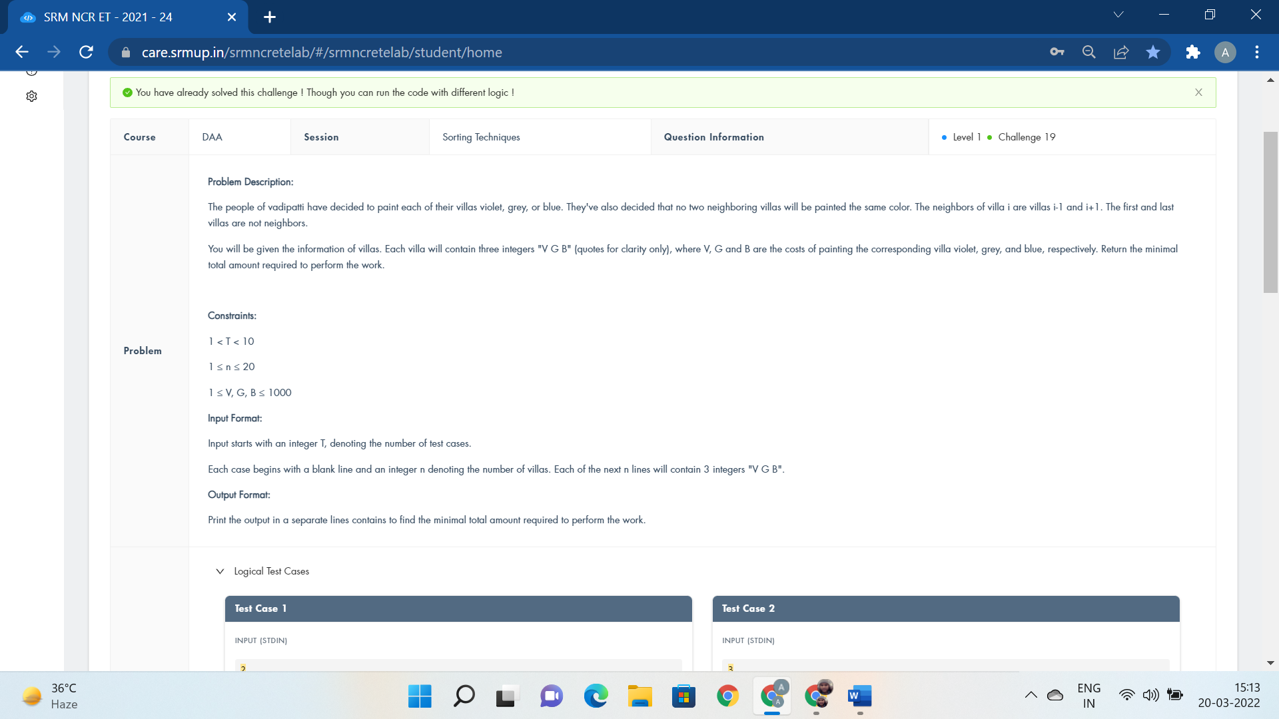

#include<bits/stdc++.h>

using namespace std;

#define fainou ios_base::sync_with_stdio(false);cin.tie(NULL)

#define ll long long

#define mod 1000000007

void solve(){

cout<<"for(i=0;i<tc;i++) for(j=0;j<N;j++)for(j=1;j<N;j++)";

}

int main(){

fainou;

ll t;

cin>>t;

int i=1;

while(t--){

ll n;

cin>>n;

ll a[n][3],ans;

cin>>a[0][0]>>a[0][1]>>a[0][2];

for(ll i=1;i<n;i++){

cin>>a[i][0]>>a[i][1]>>a[i][2];

a[i][0]+=min(a[i-1][1],a[i-1][2]);

a[i][1]+=min(a[i-1][0],a[i-1][2]);

a[i][2]+=min(a[i-1][0],a[i-1][1]);

}

ans=min(a[n-1][0],a[n-1][1]);

ans=min(a[n-1][2],ans);

cout<<"Line "<<i++<<": "<<ans<<"\n";

}

}

Shankar is a volleyball trainer at government school in madurai:-

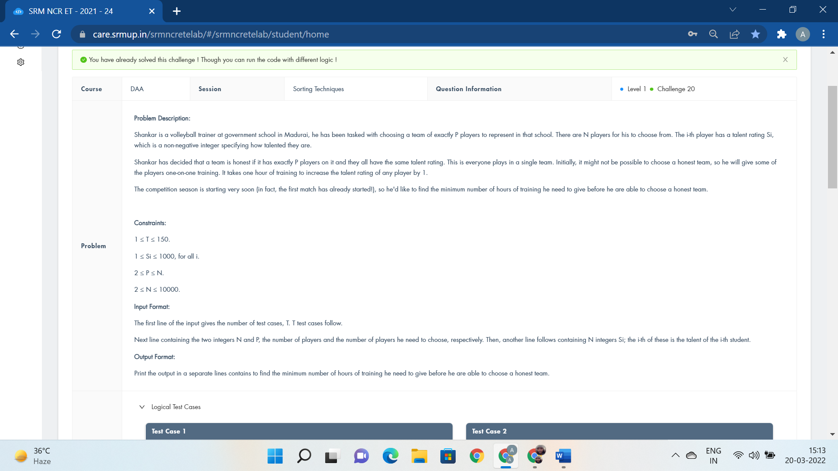

#include<bits/stdc++.h>

using namespace std;

typedef long long LL;

const int N = (int) 1e6 + 6, mod = (int) 0;

int a[N];

long long sum[N];

int main() {

int tc;

cin >> tc;

for (int tt = 1; tt <= tc; ++tt) {

int n, p;

cin >> n >> p;

for (int j = 0; j < n; ++j)

cin >> a[j];

sort(a, a + n);

int i;

for(i=0;i<n;i++)

sum[i + 1] = sum[i] + a[i];

long long res = 1e18;

for (int j = p - 1; j < n; ++j) {

long long s = sum[j + 1] - sum[j - (p - 1)];

long long cost = (LL) a[j] * p - s;

res = min(res, cost);

}

cout << res << '\n';

}

}